**The Software Requirements Specification(SRS) is one of the first phases of system development. This phase results in the Software Requirements Specification(SRS) document, which must contain a complete, concise, high-quality description of the system being considered.**

Software Requirement Document: Student Clearance

**Sustainable Outreach And Universal**

**Leadership (SOUL) Limited**

Table of Content

A. Abstract 3

B. Introduction 3

Purpose 3

Scope 3

C. Definition, Acronyms and Abbreviations 3

D. Overview of the Document 3

G. Detailed requirement 3

H. WSC Student Clearance Flowchart 4

I. Flowchart Description 4

J. Overall Screens and Their Descriptions 4

1. Clearance Master 5

General Description 5

Screenshot 5

Field list 5

Users: Roles and Permissions 5

2. Student Clearance Application 6

General Description 6

Screenshot 6

Field list 7

Users: Roles and Permissions 8

# Abstract

Software Requirements Specification (SRS) is one of the first phases of system development. This phase results in the Software Requirements Specification (SRS) document, which must contain a complete, concise, high-quality description of the system being considered.

# Introduction

## Purpose

This document covers the functional requirements for Student Clearance in the Education module in ERP Product.

## Scope

The scope of this requirement document includes

# Definition, Acronyms and Abbreviations

The following table explains the terms and abbreviations used in the document:

|  |  |
| --- | --- |
| **Abbreviation** | **Description** |
| SRS | Software Requirements Specification |
|  |  |
|  |  |
|  |  |

# Overview of the Document

Students who wish to receive their Temporary Graduation Certificate or Diploma (once they have received an e-mail notification stating that it is ready) or those who wish to discontinue their studies at the Institution must go through the clearance procedure themselves.

This document captures the requirements for the Student Clearance process in an ERP system. The clearance will be determined if the student has gone through the procedure and has got clearance from the respective departments, which eventually leads to disabling the user from the system.

# Detailed requirement

(needs to be discussed)

# WSC Student Clearance Flowchart

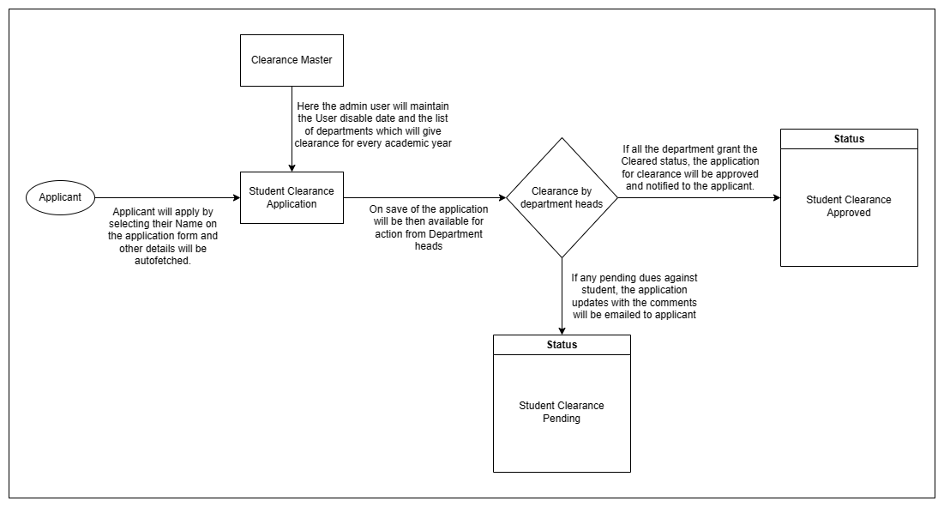

# Flowchart Description

The above flowchart explains the flow of the student clearance process from the applicant applying for the clearance till they receive the approval. Apart from the applicant, department heads will also have access to this screen once the applicant saves the form. The department heads can also raise comments if there is any outstanding due which will be notified to the applicant via email.

# Overall Screens and Their Descriptions

|  |  |  |
| --- | --- | --- |
| Sl no | Screen Name | Description |
|  | Clearance Master | In this screen the user can maintain the academic year, User disable date, and the list of departments from whom the clearance is required for the student belonging to the aforementioned academic year. |
|  | Student Clearance Application | The Student clearance Application screen will allow users to apply for clearance once the enrolled course is completed successfully. The student user will select their name and just save. After which, an email will be sent to all the departments mentioned in the application for clearance approval. If any dues is pending against the student in any of the departments, the user can leave a comment which will again trigger a mail notifying the student about the pending dues. |

1. Clearance Master

## General Description

This is a master screen for Student Clearance Application, in this screen the user can maintain the academic year, User disable date, and the list of departments from whom the clearance is required for the student belonging to the aforementioned academic year.

The following table describes overall information about this screen:

|  |  |
| --- | --- |
| **Description** | 1. Admin user will select and add Academic Year. 2. Admin user will select and add User Disable Date. 3. Admin user will click on add row and enter department names from where clearance needs to be obtained. 4. Admin user will click the save button and the record will be saved |
| **Navigation** | Home > Admission> Admission> Clearance Master |
| **Pre-requisites** | The system should have records in the following screen   1. Academic Year 2. Department |

## Screenshot

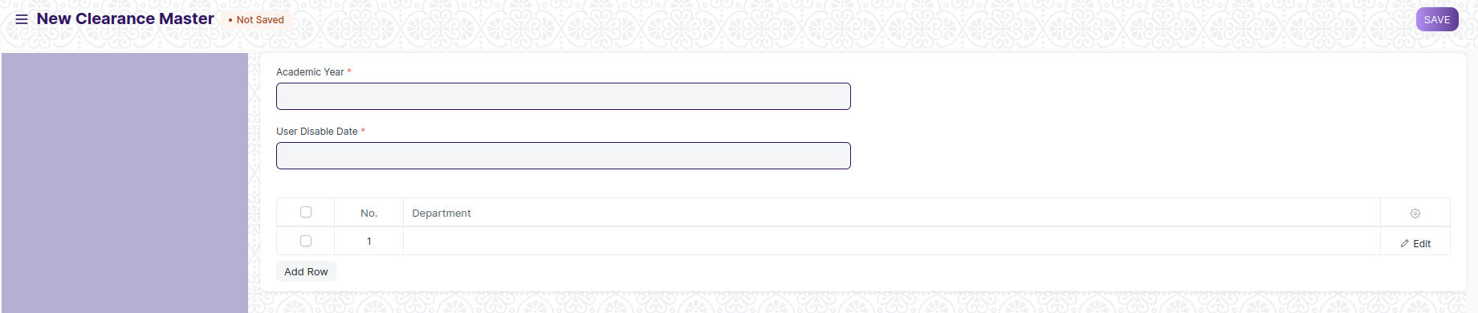

Figure 1: Clearance Master Screen

## Field list

The following table describes the UI fields present on this screens:

|  |  |  |  |  |  |
| --- | --- | --- | --- | --- | --- |
| 1. No. | Field Name | Field Type | Validation/Action | Mandatory | Remarks |
| 1 | Academic Year | Link | Academic Year | Y |  |
| 2 | User Disable Date | Date picker |  | Y |  |
| 3 | **Clearance Departments** | Table |  | Y | Fields described in the table below |

|  |  |  |  |  |
| --- | --- | --- | --- | --- |
| **Clearance Departments** | | | | |
| S. No. | Field Name | Field Type | Validation/Action | Mandatory |
| 1 | Department | Link | Fetched from master screen Department |  |

## Users: Roles and Permissions

The following table describes the users and their roles and permissions for the screens:

|  |  |  |  |  |  |  |  |  |  |
| --- | --- | --- | --- | --- | --- | --- | --- | --- | --- |
| ID | Role | Select | Read | Write | Create | Delete | Submit | Cancel | Amend |
| 1 | [Education Administrator](http://localhost:8000/app/permission-manager/Photocopy Application) | Yes | Yes | Yes | Yes | Yes | NA | NA | NA |
| 2 | [System Manager](http://localhost:8000/app/permission-manager/Photocopy Application) | No | Yes | Yes | Yes | Yes | NA | NA | NA |

# **2. Student Clearance Application**

## General Description

The Student clearance Application screen will allow users to apply for clearance once the enrolled course is completed successfully. The student user will select their name and just save. After which, an email will be sent to all the departments mentioned in the application for clearance approval. If any dues is pending against the student in any of the departments, the user can leave a comment which will again trigger a mail notifying the student about the pending dues.

Once all the Department administrator user check marks the cleared check box in the screen, the status of the application will turn to “Clearance Approved” from “Clearance Pending” which will trigger one final email notifying the student about the approval of their Clearance Application.

The following table describes overall information about this screen:

|  |  |
| --- | --- |
| **Description** | 1. Student user will select and add Student ID and other related details like student name and current academic detail will be auto fetched. 2. Based on the Academic year the User Disable date will also be fetched from the Clearance master.   3. Along with User Disable date the table will be auto populated with the department names from where the clearance needs to be obtained.  4.Student user will click the save button and the records will be saved.  5. The department administrator user will select the check mark button if the student can be cleared from their department and save.  6. Once all the check boxes are selected, the status of the application will turn to “Clearance Approved” otherwise it will remain to be “Clearance Pending”.  7. Finally, user will then submit for successful submission of records. |
| **Navigation** | Home > Admission> Admission> Student Clearance Application |
| **Pre-requisites** | The system should have records in the following screen   1. Clearance Master. 2. Student |

## Screenshot

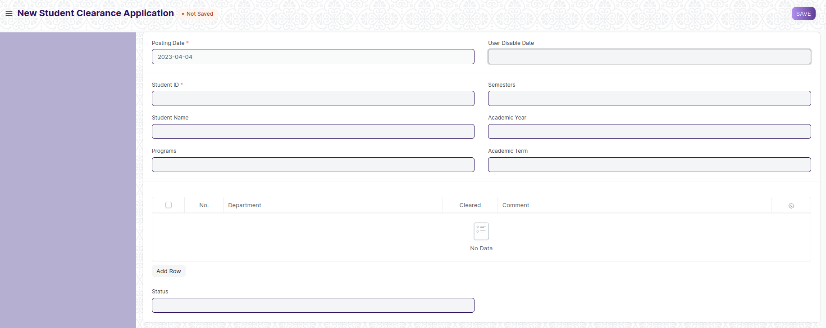

Figure 2: Student Clearance Application Screen

## Field list

The following table describes the UI fields present in this screens:

|  |  |  |  |  |  |
| --- | --- | --- | --- | --- | --- |
| S. No. | Field Name | Field Type | Validation/Action | Mandatory | Remarks |
| 1 | Posting Date | Date | Today’s date |  |  |
| 2 | User Disable Date | Date | Auto fetched from Clearance Master based on Academic year |  |  |
| 3 | Student ID | Link | Fetched From Master Screen Student | Y |  |
| 4 | Student Name | Text | Auto Fetched From Master Screen Student |  |  |
| 5 | Programs | Text | Auto Fetched From Master Screen Student |  |  |
| 6 | Semesters | Text | Auto Fetched From Master Screen Student |  |  |
| 7 | Academic Year | Text | Auto Fetched From Master Screen Student |  |  |
| 8 | Academic Term | Text | Auto Fetched From Master Screen Student |  |  |
| 9 | Departments Clearance Status | Table |  | Y | Fields described in the table below |
| 10 | Status | Text | Auto updated to Clearance Approved/Clearance Pending based on the “Departments Clearance Status” table. |  |  |

|  |  |  |  |  |
| --- | --- | --- | --- | --- |
| **Departments Clearance Status** | | | | |
| S. No. | Field Name | Field Type | Validation/Action | Mandatory |
| 1 | Department | Link | Auto Fetched From Clearance Departments child table |  |
| 2 | Cleared | Check box | User Input |  |
| 3 | Comment | Text | User Input |  |

## Users: Roles and Permissions

The following table describes the users and their roles and permissions for the screens:

|  |  |  |  |  |  |  |  |  |  |
| --- | --- | --- | --- | --- | --- | --- | --- | --- | --- |
| ID | Role | Select | Read | Write | Create | Delete | Submit | Cancel | Amend |
| 1 | [Education Administrator](http://localhost:8000/app/permission-manager/Photocopy Application) | Yes | Yes | Yes | Yes | Yes | Yes | Yes | Yes |
| 2 | [System Manager](http://localhost:8000/app/permission-manager/Photocopy Application) | No | Yes | Yes | Yes | Yes | No | Yes | No |
| 3 | [Student](http://localhost:8000/app/permission-manager/Photocopy Application) (Only if creator) | Yes | Yes | Yes | Yes | Yes | Yes | Yes | No |
| 4 | [Student](http://localhost:8000/app/permission-manager/Photocopy Application) (After Submission) | No | Yes | No | No | No | No | Yes | No |
| 5 | Department Administrator | Yes | Yes | Yes | Yes | No | Yes | No | No |